

**Project: Online Shop Management Software**

SUMMER 2021

Department of CSE

CSE 103

SEC: 05

Instructed by Dr Ahmed Wasif Reza

Associate Professor

Department of CSE

This Project is created by

Group Serial: 03

Name: Suraiya Nusrat Tanha

ID : 2021-2-60-030

Name: Umme Habiba Fariha

ID : 2021-2-60-079

Name: Shah Abdul Mazid

ID : 2021-2-60-046

Date of Submission: 16.09.2021

CSE 103-Structured Programing

Project Evaluation Rubrics

|  |  | **Max.** |  | **Awarded** |
| --- | --- | --- | --- | --- |
|  | |  |  |  |
| **A. Report** | |  |  |  |
|  |  |  |  |  |
| i. | Introduction / Problem statement |  |  |  |
|  |  |  |  |  |
| iv. | System Design |  |  |  |
|  |  |  |  |  |
| v. | Program output (Screen shots) |  |  |  |
|  |  |  |  |  |
| vi. | Source code |  |  |  |
|  | |  |  |  |
| vii. Disk/CD neatly attached (Y/N) | |  |  |  |
|  | |  |  |  |
|  | |  |  |  |
| **B. Source Code** | |  |  |  |
|  |  |  |  |  |
| i. | Style |  |  |  |
|  |  |  |  |  |
|  | Indentation |  |  |  |
|  |  |  |  |  |
|  | Self-documentation |  |  |  |
|  |  |  |  |  |
| ii. | Modularity (small size functions) |  |  |  |
|  |  |  |  |  |
| iii. | Error reporting capabilities |  |  |  |
|  |  |  |  |  |
| iv. | Code efficiency, strategy, and originality |  |  |  |
|  | |  |  |  |
|  | |  |  |  |
| **C. Program Execution** | |  |  |  |
|  |  |  |  |  |
| i. | Compile without errors |  |  |  |
|  |  |  |  |  |
| ii. | User friendly |  |  |  |
|  |  |  |  |  |
| iii. | Error free during runtime |  |  |  |
|  |  |  |  |  |
| iv. | Program output |  |  |  |
|  | |  |  |  |
|  | |  |  |  |
| **D. Presentation and Demonstration [Psychomotor Domain]** | |  |  |  |
|  | |  |  |  |
| i.  Presentation and communication skills (**Soft skill)** | |  |  |  |
|  | |  |  |  |
|  | |  |  |  |
| **E. Bonus** | |  |  |  |
|  |  |  |  |  |
| i. | Extra significant features |  |  |  |
|  |  |  |  |  |
|  | **TOTAL** |  | **11** |  |
|  |  |  |  |  |

CSE 103-Structured Programing

Project Declaration

**Student 1**

| **Student ID** | 2021-2-60-030 |
| --- | --- |
| **Name** | Suraiya Nusrat Tanha |
| **Session** | Summer 2021 |
| **Project No.** | 09 |
| **Date submitted** | 16 September 2021 |
| **Deadline of the project** | 16 September 2021 |
| **My contribution in doing this**  **project (in percentage) in the group** | 35% |
| **Description of my contribution in this**  **project in the group** | Developing source code (Admin panel, purchase, review panel, offers, etc. idea) and Report |
| **Number of hours I spent in doing this**  **project** | Around 55 hours |

**Student 2**

| **Student ID** | 2021-2-60-79 |
| --- | --- |
| **Name** | Umme Habiba Fariha |
| **Session** | Summer 2021 |
| **Project No.** | 09 |
| **Date submitted** | 16 September 2021 |
| **Deadline of the project** | 16 September 2021 |
| **My contribution in doing this**  **project (in percentage) in the group** | 35% |
| **Description of my contribution in this**  **project in the group** | Developing source code (offers, purchase, color adjust etc. idea) and Report |
| **Number of hours I spent in doing this**  **project** | Around 55 hours |

**Student 3**

| **Student ID** | 2021-2-60-046 |
| --- | --- |
| **Name** | Shah Abdul Mazid |
| **Session** | Summer 2021 |
| **Project No.** | 09 |
| **Date submitted** | 16 September 2021 |
| **Deadline of the project** | 16 September 2021 |
| **My contribution in doing this**  **project (in percentage) in the group** | Developing source code (review panel, color adjust etc. idea) and Report |
| **Description of my contribution in this**  **project in the group** | 30% |
| **Number of hours I spent in doing this**  **project** | Around 50 hours |

**We hereby certify that this project represents the work done by all our group members with our contribution clearly stated above without copying from any other resources. We declare that no part of our work has been copied from or by other groups, and that no collusion has taken place with any other persons or groups. We certify that any disks submitted with this project have been virus checked and have no viruses on them.**

**(1) Signature: …………………………… Date: ........................................**

**(2) Signature: …………………………… Date: ........................................**

**(3) Signature: …………………………… Date: .......................................**

**Introduction**

An online shop management system is a form of e-commerce system. Since the world is progressing in technology and finding ways of doing necessary work through the fastest routes, many aspects like e-commerce are being established.

In this online shop management system, we develop the system by using a C program. There is an admin panel, a customer panel, a review panel and exit side. Only the admin has access to the admin panel and they can login by using their emails and there are four admins (Dr. Wasif Ahmed Reza, Suraiya Nusrat Tanha, Umme Habiba Fariha and Shah Abdul Mazid).  Admins can keep check of the products in stock and can add or delete products if needed. They can view products by product ID or name. Here in the customer panel, customers can choose their desired product and add it to the cart by using product id or name. After this they can proceed with the purchase and there will be a billing system where purchased items, their quantity and total price will be shown together with the price after including voucher discounts and offers. There are “BOGO”, “BUMPERS” and “FREE DELIVERY” offers for the customers. Here we used “wasif sir” as the voucher code. Then we added a review panel where customers can give their review. And lastly, we added the exit side.

We tried our best to create a perfect code for this online shop management system by using c programming.

**System Design**

**Flowchart**

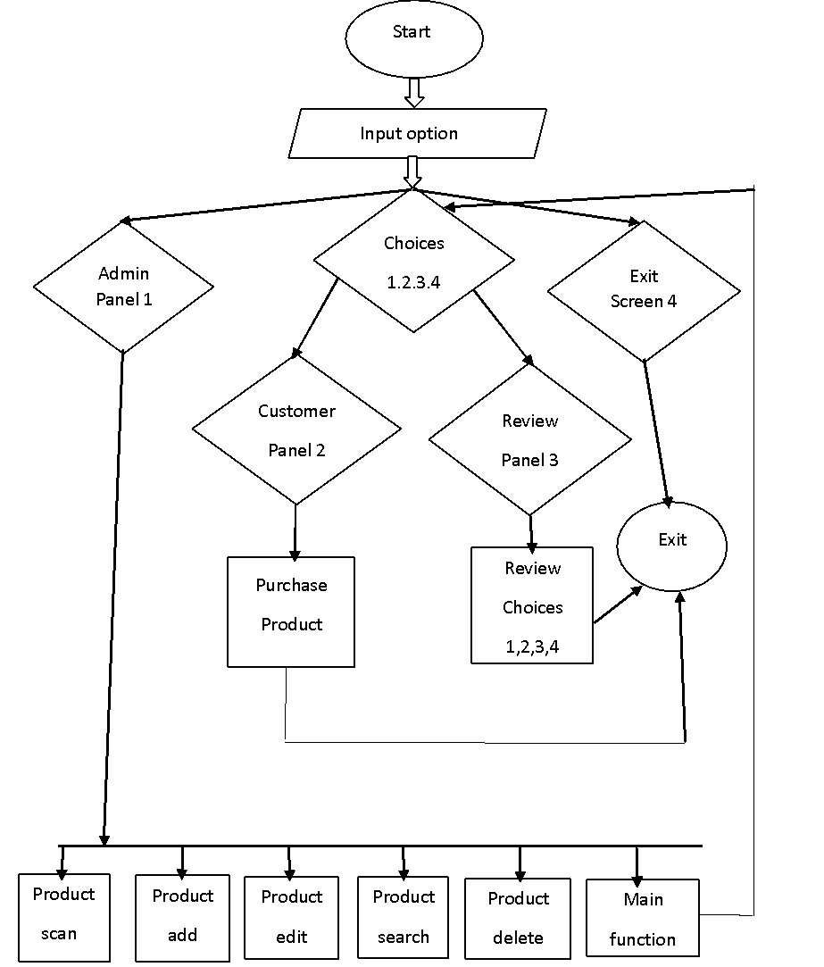

**Program output/screenshots**

1.Intro

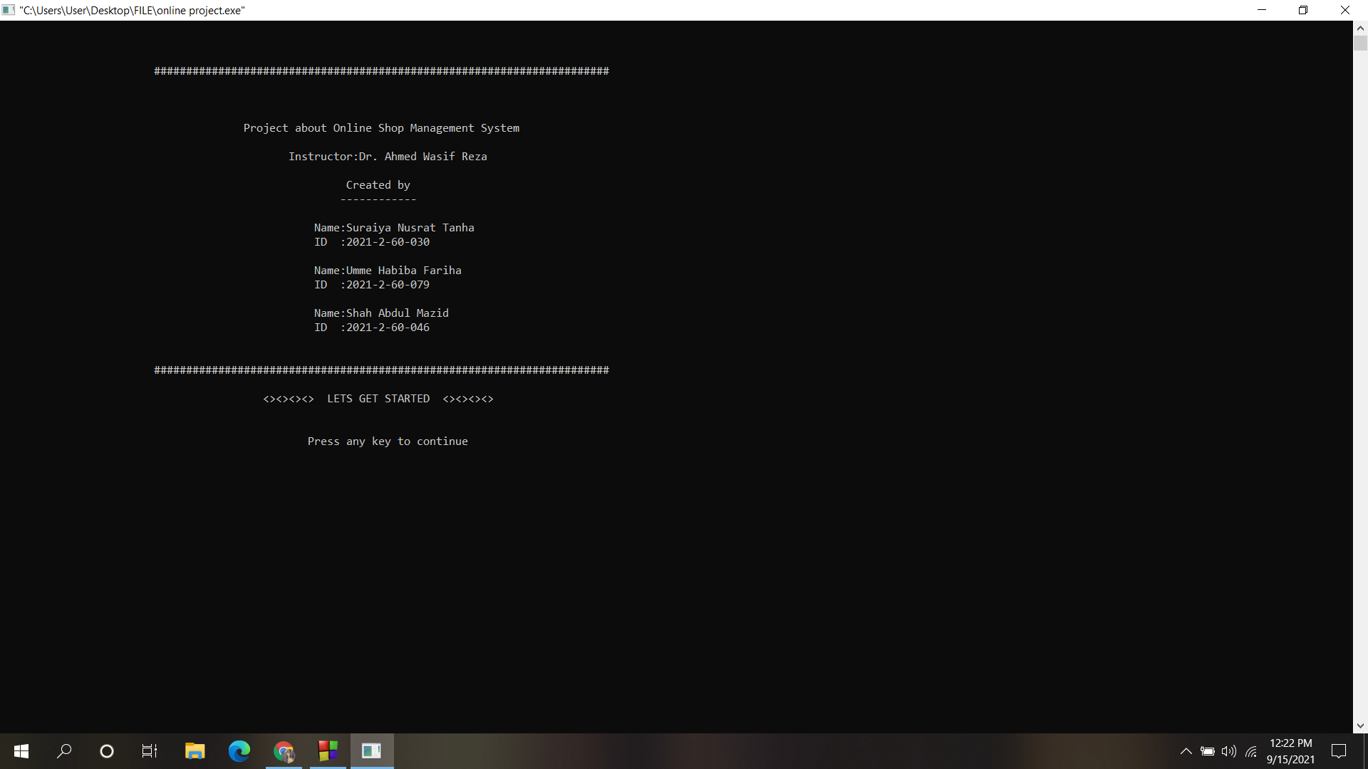

2. Home screen(choices)

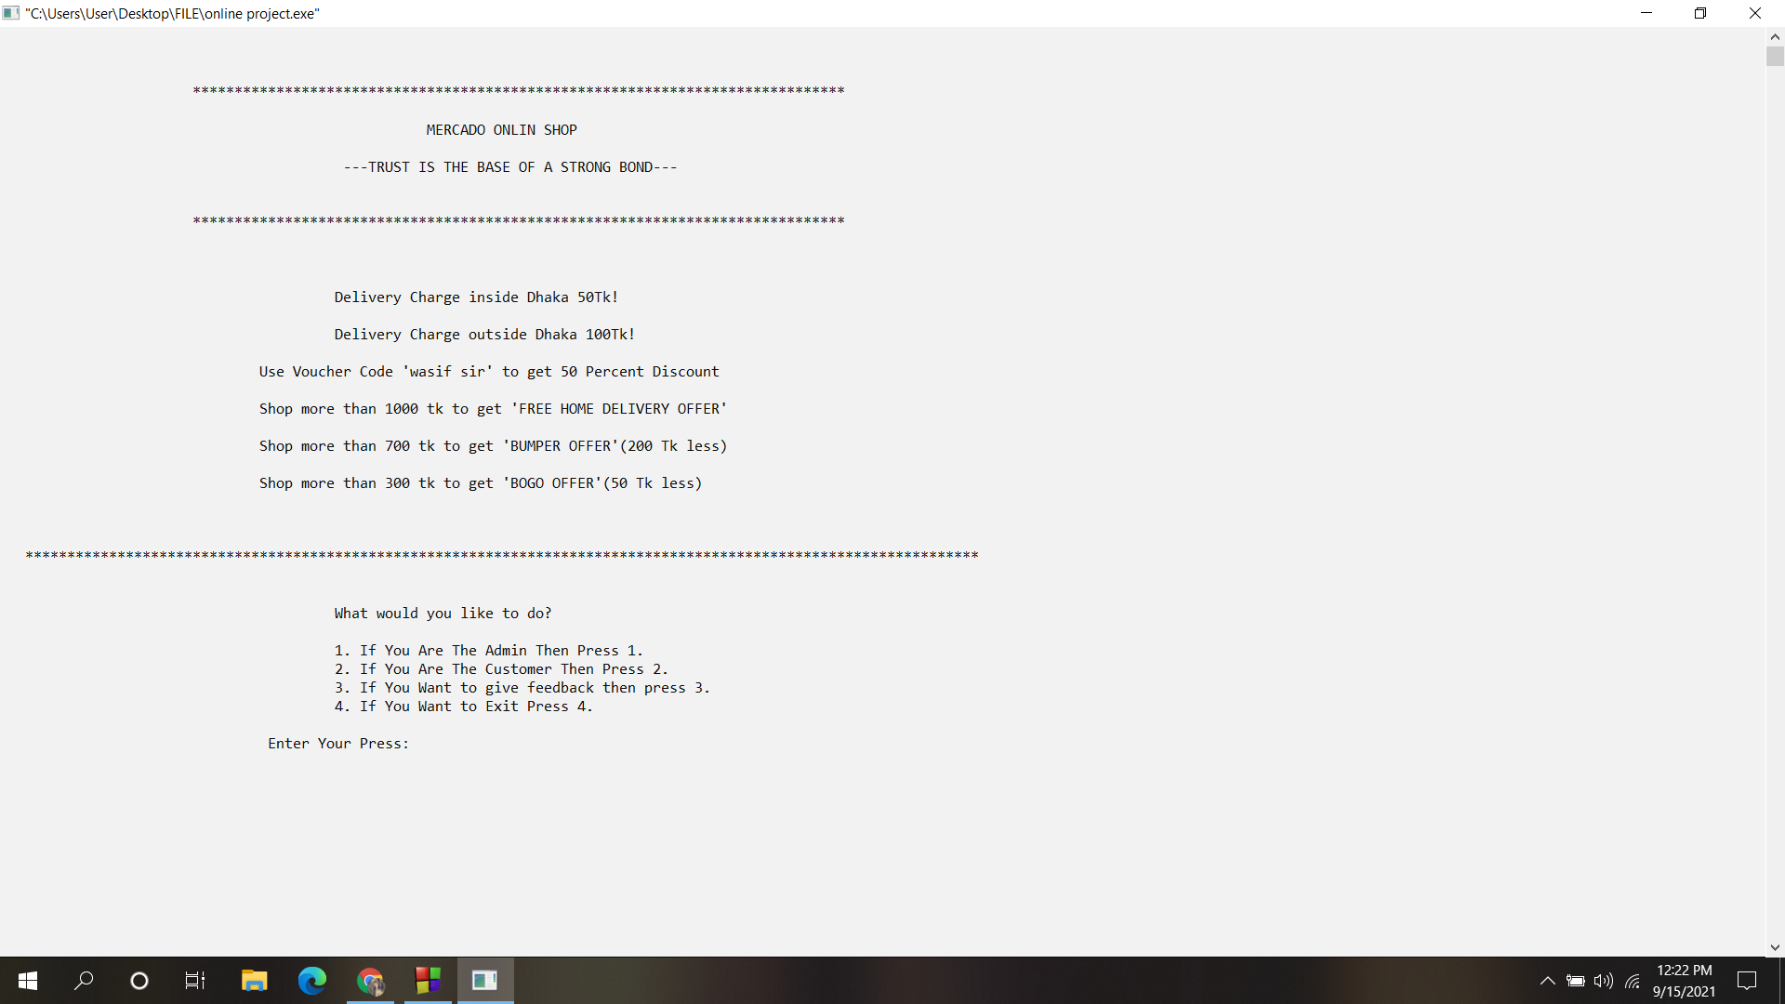

3. Admin Access

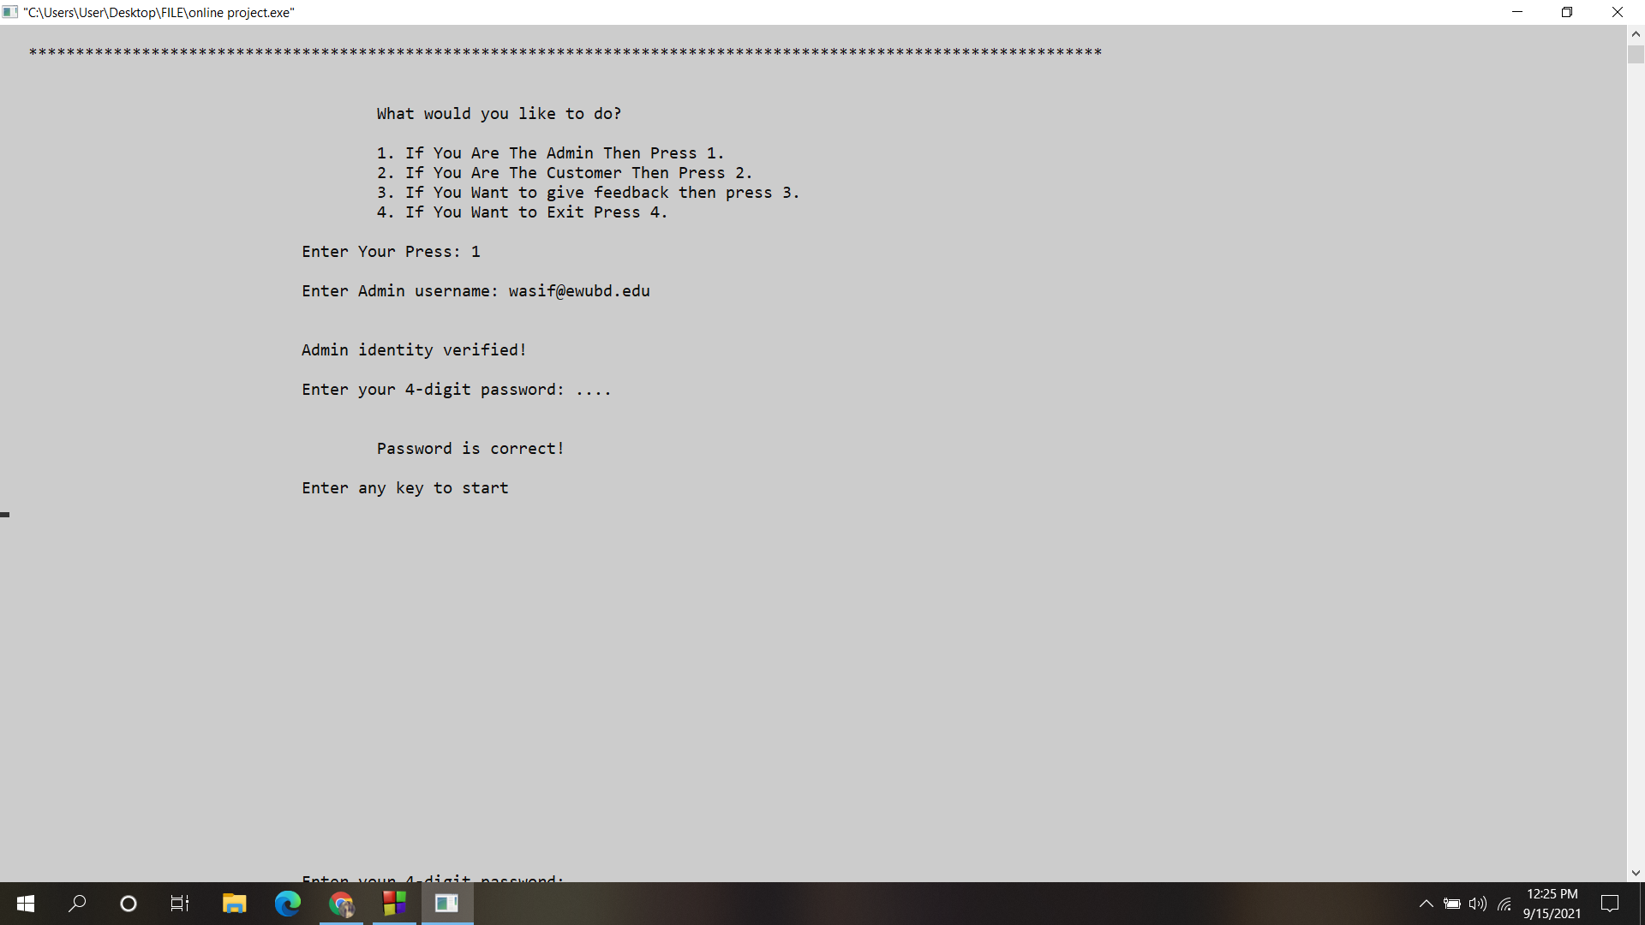

4. Admin panel

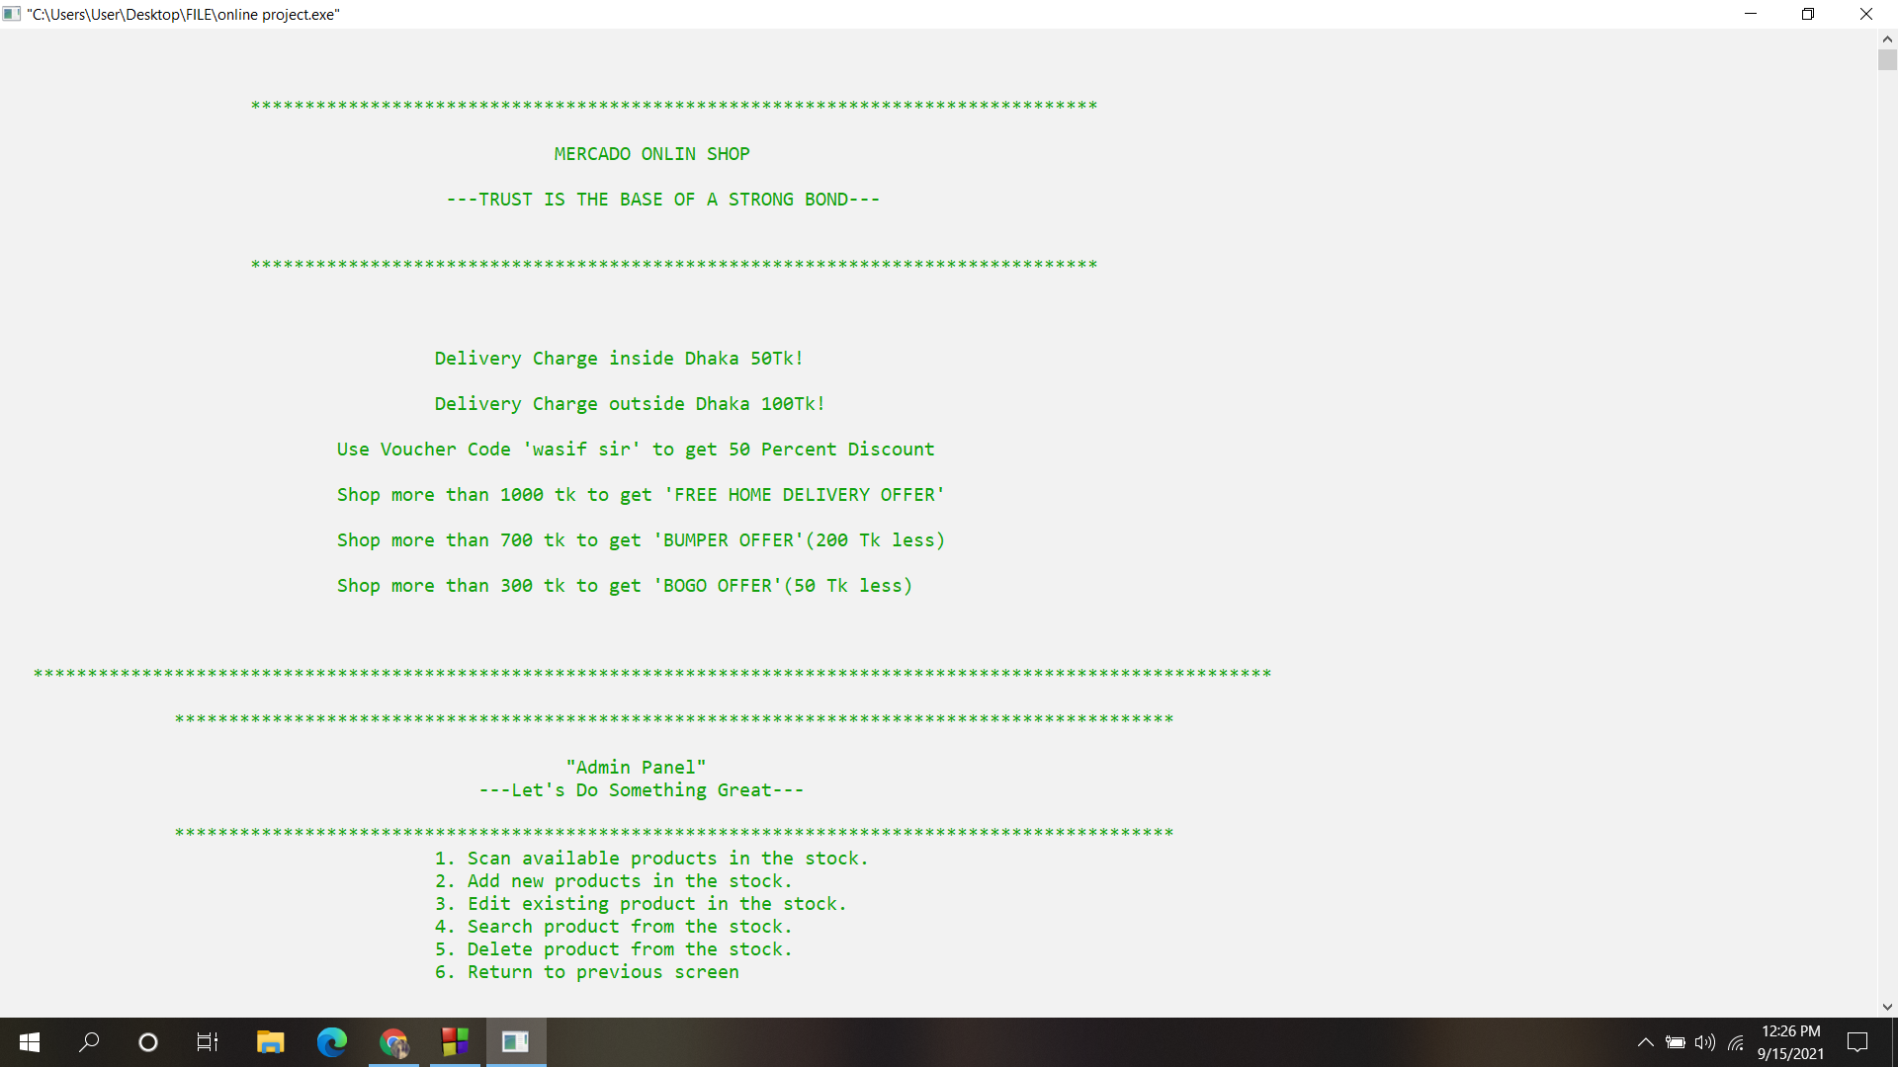

5. Customer Panel

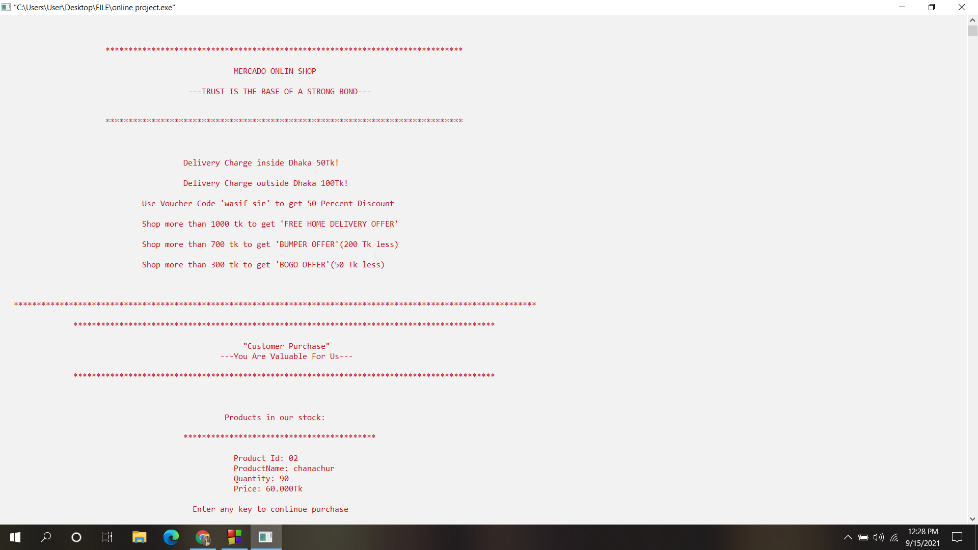

6.Receipt

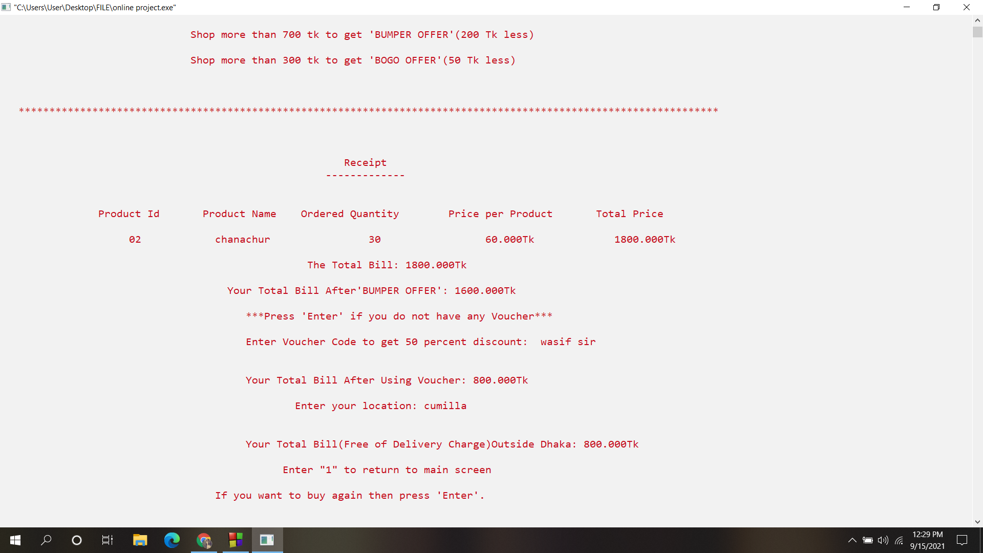

7. Review

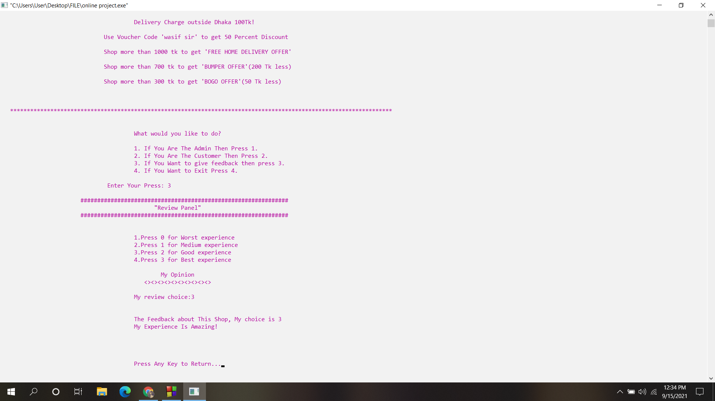

8. Exit panel

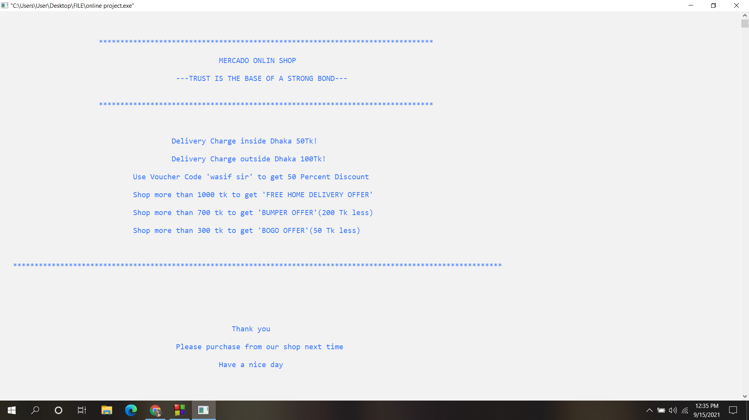

**Limitations**

1. There’s an error in receipt system.

2. Taking user input becomes difficult because

of a functional error in code blocks so the user has to quit code blocks in some cases.

**Extra Features**

1.We added delivery option both in inside and outside of Dhaka.

2.Voucher benefit is provided with voucher code.

3. Delivery charge free offer for special

purchase.

4. Offers like ”BOGO” and ”BUMPER” offers are included.

5. Admin can easily login by their emails.

6. Admin password is protected with dot privacy.

7. Customer can give their review.

8. As the code is very flexible, the user can easily modify the code.

**Appendix(Source Code)**

#include<stdio.h>

#include<conio.h>

#include<stdlib.h>

#include<string.h>

#define error puts("\n\t\t\t\t\t\t ><><><><><><><><\n\t\t\t\t\t\t < \a! ERROR ! > \n\t\t\t\t\t\t ><><><><><><><><")

//Intro

void title();

//Screen Headings

int fixed_title(int);

void admin_panel();

void customer_panel();

//Admin side

int access();

void admin_permission();

void product_scan();

void product_add();

void product_edit();

void product_search();

void product_delete();

//Customer side

int customer_purchase();

void review();

//Declaring file for stock

FILE *fptr;

//Declaring structure for stock

struct store

{

char ProductId[1000];

char ProductName[1000];

int quantity;

int want;

float price;

} ;

int counter;

int cas=0;

//main start

int main()

{

struct store STORE;

int press;

int a;

title();

fixed_title(0);

system("color F0");

puts("\n\n\t\t\t\t\tWhat would you like to do?");

puts(" \n\t\t\t\t\t1. If You Are The Admin Then Press 1.");

puts(" \t\t\t\t2. If You Are The Customer Then Press 2.");

puts(" \t\t\t\t3. If You Want to give feedback then press 3.");

puts(" \t\t\t\t4. If You Want to Exit Press 4.");

printf("\n\t\t\t\tEnter Your Press: ");

scanf("%d",&press);

switch (press)

{

case 1 :

{

system("color 70");

a=access();

if(a==1)

admin_permission();

else

{

getch();

main();

}

break;

}

case 2 :

{

customer_purchase();

break;

}

case 3 :

{

review();

getch();

main();

break;

}

default :

{

fixed_title(0);

system("color F9");

puts("\n\n\n\n\n\n\t\t\t\t\t\t Thank you");

puts("\n\t\t\t\t\t Please purchase from our shop next time");

puts("\n\t\t\t\t\t\t Have a nice day");

fclose(fptr);

getch();

exit(0);

}

}

}

void title()

{

system("cls");

system("color 7");

printf("\n\n\n\t\t\t#######################################################################");

printf("\n\n\n\n\t\t\t\t Project about Online Shop Management System\n");

printf("\n\t\t\t\t\t Instructor:Dr. Ahmed Wasif Reza");

printf("\n\n\t\t\t\t\t\t Created by \n");

printf("\t\t\t\t\t\t ------------ \n");

printf("\n\t\t\t\t\t Name:Suraiya Nusrat Tanha");

printf("\n\t\t\t\t\t ID :2021-2-60-030");

printf("\n\n\t\t\t\t\t Name:Umme Habiba Fariha");

printf("\n\t\t\t\t\t ID :2021-2-60-079");

printf("\n\n\t\t\t\t\t Name:Shah Abdul Mazid");

printf("\n\t\t\t\t\t ID :2021-2-60-046");

printf("\n\n\n\t\t\t#######################################################################");

puts("\n\n\t\t\t\t\t <><><><> LETS GET STARTED <><><><>");

puts("\n\n\t\t\t\t\t Press any key to continue");

getch();

}

int fixed_title(int ftitle)

{

system("cls");

printf("\n\n\n\t\t ******************************************************************************\n");

printf("\n\t\t\t\t\t\t MERCADO ONLIN SHOP\n");

printf("\n\t\t\t\t\t ---TRUST IS THE BASE OF A STRONG BOND---\n");

printf("\n\n\t\t ******************************************************************************\n");

printf("\n\n\n\t\t\t\t Delivery Charge inside Dhaka 50Tk!");

printf("\n\n\t\t\t\t Delivery Charge outside Dhaka 100Tk!");

printf("\n\n\t\t\t Use Voucher Code 'wasif sir' to get 50 Percent Discount");

printf("\n\n\t\t\t Shop more than 1000 tk to get 'FREE HOME DELIVERY OFFER'");

printf("\n\n\t\t\t Shop more than 700 tk to get 'BUMPER OFFER'(200 Tk less)");

printf("\n\n\t\t\t Shop more than 300 tk to get 'BOGO OFFER'(50 Tk less)");

printf("\n\n\n\n ******************************************************************************************************************\n");

}

void admin_panel()

{

printf("\n\t\t********************************************************************************************\n");

printf("\n\t\t\t\t\t\t \"Admin Panel\"\n");

printf("\t\t\t\t\t ---Let's Do Something Great---\n");

printf("\n\t\t********************************************************************************************\n");

}

void customer_panel()

{

printf("\n\t\t********************************************************************************************\n");

printf("\n\t\t\t\t\t\t \"Customer Purchase\"\n");

printf("\t\t\t\t\t\t---You Are Valuable For Us---\n");

printf("\n\t\t********************************************************************************************\n");

}

int access()

{

fflush(stdin);

char admin[1000];

static char password[100];

int a;

printf("\n\t\t\t\tEnter Admin username: ");

scanf("%s",&admin);

if(strcmpi(admin,"wasif@ewubd.edu")==0 || strcmpi(admin,"suraiya030@gmail.com")==0 || strcmpi(admin,"habiba079@gmail.com")==0 || strcmpi(admin,"mazid046@gmail.com")==0)

{

puts("\n\n\t\t\t\tAdmin identity verified!");

printf("\n\t\t\t\tEnter your 4-digit password: ");

for(int i=0; i<4; i++)

{

password[i]=getch();

if(password[i]=='\r')

{

break;

}

else

printf(".");

}

if(strcmp(password,"2021")==0)

{

puts("\a\n\n\n\t\t\t\t\tPassword is correct!");

puts("\a\n\t\t\t\tEnter any key to start");

getch();

a=1;

}

else

{

puts("\a\n\n\n\t\t\t\t\tWrong password!");

a=0;

}

}

else

{

fixed_title(0);

puts("\a\n\n\n\t\t\t\t\t\t User is unknown!");

a=0;

}

return a;

}

void admin_permission()

{

system("color F2");

int c;

fptr=fopen("stockinfofile.txt","ab+");

fseek(fptr,0,0);

fixed_title(0);

admin_panel();

printf("\t\t\t\t\t1. Scan available products in the stock.");

printf("\n\t\t\t\t\t2. Add new products in the stock.");

printf("\n\t\t\t\t\t3. Edit existing product in the stock.");

printf("\n\t\t\t\t\t4. Search product from the stock.");

printf("\n\t\t\t\t\t5. Delete product from the stock.");

printf("\n\t\t\t\t\t6. Return to previous screen\n");

printf("\n\n\t\t\t\t\tEnter a choice: ");

scanf("%d",&c);

switch (c)

{

case 1 :

product_scan();

break;

case 2 :

product_add();

break;

case 3 :

product_edit();

break;

case 4 :

product_search();

break;

case 5 :

product_delete();

break;

case 6 :

main();

}

}

void product_scan()

{

struct store STORE;

fixed_title(0);

admin_panel();

printf("\n\t\t\t Choice 01: Scanning available products");

printf("\n\t\t\t");

printf("******************************************************************");

rewind(fptr);

while(fread(&STORE,sizeof(STORE),1,fptr)==1)

{

printf("\n\t\t\t ");

printf("***************************************************************");

printf("\n\t\t\t\t\t\tProduct Id: ");

puts(STORE.ProductId);

printf("\t\t\t\t\t\tProductName: ");

puts(STORE.ProductName);

printf("\t\t\t\t\t\tQuantity: ");

printf("%d",STORE.quantity-cas);

printf("\n\t\t\t\t\t\tPrice: ");

printf("%.3fTk",STORE.price);

}

printf("\n\t\t\t\t Press any key to return main menu...\n");

getch();

system("cls");

fclose(fptr);

admin_permission();

}

void product_add()

{

struct store STORE;

fixed_title(0);

char id1[1000];

char id2[1000];

admin_panel();

printf("\n\t\t\tChoice 02: Addition of new products by the perspective of customer demands ");

printf("\n\n\t\t");

printf("********************************************************************************************");

fflush(stdin);

printf("\n\n\t\t\t\t\t\t Product Id: ");

gets(id1);

while(fread(&STORE,sizeof(STORE),1,fptr)==1)

{

if(((strcmpi(STORE.ProductId,id1))==0))

{

error;

printf("\n\t\t\t\t\t Sorry! This product is already in our stock.\n");

printf("\n\t\t\t\t Enter any key to add new product....\n");

getch();

product_add();

}

}

strcpy(STORE.ProductId,id1);

printf("\n\t\t\t\t\t\t Product Name: ");

gets(id2);

while(fread(&STORE,sizeof(STORE),1,fptr)==1)

{

if(((strcmpi(STORE.ProductName,id2))==0))

{

printf("\nSame Products Name With Different ID Added. \n");

getch();

product_add();

}

}

strcpy(STORE.ProductName,id2);

printf("\n\t\t\t\t\t\t Quantity: ");

scanf("%d",&STORE.quantity);

printf("\n\t\t\t\t\t\t Price: ");

scanf("%f",&STORE.price);

fwrite(&STORE,sizeof(STORE),1,fptr);

printf("\n\t\t\t\t Enter any key to return in main menu...\n");

getch();

fclose(fptr);

admin_permission();

}

void product_edit()

{

struct store STORE;

fflush(stdin);

fixed_title(0);

admin_panel();

FILE *tptr;

printf("\n\t\t\t\t Choice 03: Modify the products in stock");

printf("\n\t\t\t ");

printf("******************************************************************");

char id[1000];

int a=0;

char option[1000];

printf("\n\n\t\t\t\t\t I want to edit by: ");

gets(option);

if(strcmpi(option,"Id")==0)

{

char another='y';

while(another=='y' || another=='Y')

{

fflush(stdin);

printf("\n\n\n\t\t\t\t\t Enter product ID to edit: ");

gets(id);

tptr=fopen("temporary.txt","wb");

rewind(fptr);

int flag=0, flag1=0, flag2;

while(fread(&STORE,sizeof(STORE),1,fptr)==1)

{

if(strcmpi(STORE.ProductId,id)==0)

{

flag1++;

flag2=1;

fflush(stdin);

printf("\n\t\t\t\t\t \"%s\" Product is in the stock!\n",id);

flag=10;

printf("\n\t\t\t\t\t New Product Id : ");

gets(STORE.ProductId);

printf("\n\n\t\t\t\t\t New Product Name : ");

gets(STORE.ProductName);

printf("\n\t\t\t\t\t New Quantity: ");

scanf("%d",&STORE.quantity);

printf("\n\t\t\t\t\t Price: ");

scanf("%f",&STORE.price);

if(flag1==1 && flag2==1)

{

fseek(tptr,0,0);

}

else

{

fseek(tptr,(flag1-1)*sizeof(STORE),0);

}

fwrite(&STORE,sizeof(STORE),1,tptr);

}

else

{

flag1++;

fwrite(&STORE,sizeof(STORE),1,tptr);

}

}

if(flag!=10)

{

error;

puts("\n\t\t\t\t\t This product doesn't exist in the stock!");

}

fclose(fptr);

fclose(tptr);

remove("stockinfofile.txt");

rename("temporary.txt","stockinfofile.txt");

fptr=fopen("stockinfofile.txt","ab+");

printf("\n\t\t\t\t\t Want to edit another product? (Y/N)? ");

fflush(stdin);

another = getche();

}

}

else if(strcmpi(option,"Name")==0)

{

char another='y';

while(another=='y' || another=='Y')

{

fflush(stdin);

printf("\n\n\n\t\t\t\t\t Enter product Name to edit: ");

gets(id);

tptr=fopen("temporary.txt","wb");

rewind(fptr);

int flag=0, flag1=0, flag2;

while(fread(&STORE,sizeof(STORE),1,fptr)==1)

{

if(strcmpi(STORE.ProductName,id)==0)

{

flag1++;

flag2=1;

fflush(stdin);

printf("\n\t\t\t\t\t \"%s\" Product is in the stock!\n",id);

flag=10;

printf("\n\t\t\t\t\t New Product Id : ");

gets(STORE.ProductId);

printf("\n\n\t\t\t\t\t New Product Name : ");

gets(STORE.ProductName);

printf("\n\t\t\t\t\t New Quantity: ");

scanf("%d",&STORE.quantity);

printf("\n\t\t\t\t\t Price: ");

scanf("%f",&STORE.price);

if(flag1==1 && flag2==1)

{

fseek(tptr,0,0);

}

else

{

fseek(tptr,(flag1-1)*sizeof(STORE),0);

}

fwrite(&STORE,sizeof(STORE),1,tptr);

}

else

{

flag1++;

fwrite(&STORE,sizeof(STORE),1,tptr);

}

}

if(flag!=10)

{

error;

puts("\n\t\t\t\t\t This product doesn't exist in the stock!");

}

fclose(fptr);

fclose(tptr);

remove("stockinfofile.txt");

rename("temporary.txt","stockinfofile.txt");

fptr=fopen("stockinfofile.txt","ab+");

printf("\n\t\t\t\t\t Want to edit another product? (Y/N)? ");

fflush(stdin);

another = getche();

}

}

else

{

printf("\n\t\t\t\t\t Enter Valid searching form");

}

fclose(fptr);

admin_permission();

}

void product_search()

{

struct store STORE;

int a=0;

char id[100];

fixed_title(0);

admin_panel();

fptr=fopen("stockinfofile.txt","ab+");

fflush(stdin);

printf("\n\t\t\t\t Choice 04: Search in available stock");

printf("\n\t\t\t ");

printf("******************************************************************");

char option[100];

printf("\n\n\t\t\t\t\t I want to search by : ");

gets(option);

if(strcmpi(option,"Id")==0)

{

printf("\n\n\n\t\t\t\t\t Enter products ID to search: ");

gets(id);

while(fread(&STORE,sizeof(STORE),1,fptr)==1)

{

if(strcmpi(STORE.ProductId,id)==0)

{

puts("\n\t\t\t\t **************************************************\n\t\t\t\t\t\t Product Found \n\t\t\t\t **************************************************\n");

printf("\n\n\t\t\t\t\t Product Id: ");

puts(STORE.ProductId);

printf("\n\t\t\t\t\t ProductName: ");

puts(STORE.ProductName);

printf("\n\t\t\t\t\t Quantity: ");

printf("%d",STORE.quantity);

printf("\n\n\t\t\t\t\t Price: ");

printf("%.3fTk",STORE.price);

a=1;

}

}

}

else if(strcmpi(option,"Name")==0)

{

printf("\n\n\n\t\t\t\t\t Enter products Name to search: ");

gets(id);

while(fread(&STORE,sizeof(STORE),1,fptr)==1)

{

if(strcmpi(STORE.ProductName,id)==0)

{

puts("\n\t\t\t\t **************************************************\n\t\t\t\t\t\t Product Found \n\t\t\t\t **************************************************\n");

printf("\n\n\t\t\t\t\t Product Id: ");

puts(STORE.ProductId);

printf("\n\t\t\t\t\t ProductName: ");

puts(STORE.ProductName);

printf("\n\t\t\t\t\t Quantity: ");

printf("%d",STORE.quantity);

printf("\n\n\t\t\t\t\t Price: ");

printf("%.3fTk",STORE.price);

a=1;

}

}

}

else

{

printf("\n\t\t\t\t\t Enter Valid searching form");

}

if (a!=1)

{

error;

printf("\n\t\t\t\t\t %s product doesn't exist in the stock!\n",id);

}

printf("\n\t\t\t\t enter any key to continue to previous menu....");

getch();

system("cls");

fclose(fptr);

admin_permission();

}

void product_delete()

{

struct store STORE;

fflush(stdin);

fixed_title(0);

admin_panel();

FILE *tptr;

printf("\n\t\t\t\t Choice 05: Delete existing products ");

printf("\n\t\t\t");

printf("******************************************************************");

char id[30];

int a=0;

char option[100];

printf("\n\n\t\t\t\t\t I want to delete by : ");

gets(option);

if(strcmpi(option,"Id")==0)

{

char another='y';

while(another=='y' || another=='Y')

{

fflush(stdin);

printf("\n\n\n\t\t\t\t\t Enter product id to delete: ");

gets(id);

tptr=fopen("tempdel.txt","wb");

rewind(fptr);

int flag=0;

while(fread(&STORE,sizeof(STORE),1,fptr)==1)

{

if(strcmpi(STORE.ProductId,id)!=0)

{

fwrite(&STORE,sizeof(STORE),1,tptr);

}

else if(strcmpi(STORE.ProductId,id)==0)

{

puts("\n\t\t\t\t **************************************************\n\t\t\t\t\t Product is successfully deleted \n\t\t\t\t **************************************************\n");

flag=10;

}

}

if(flag!=10)

{

error;

puts("\n\t\t\t\t\t No such record exists in our stock!");

}

fclose(fptr);

fclose(tptr);

remove("stockinfofile.txt");

rename("tempdel.txt","stockinfofile.txt");

fptr=fopen("stockinfofile.txt","ab+");

printf("\n\t\t\t\t\tDelete another product out of stock? (Y/N)? ");

fflush(stdin);

another = getch();

}

}

else if(strcmpi(option,"Name")==0)

{

char another='y';

while(another=='y' || another=='Y')

{

fflush(stdin);

printf("\n\n\n\t\t\t\t\t Enter product Name to delete: ");

gets(id);

tptr=fopen("tempdel.txt","wb");

rewind(fptr);

int flag=0;

while(fread(&STORE,sizeof(STORE),1,fptr)==1)

{

if(strcmpi(STORE.ProductName,id)!=0)

{

fwrite(&STORE,sizeof(STORE),1,tptr);

}

else if(strcmpi(STORE.ProductName,id)==0)

{

puts("\n\t\t\t\t **************************************************\n\t\t\t\t\t Product is successfully deleted \n\t\t\t\t **************************************************\n");

flag=10;

}

}

if(flag!=10)

{

error;

puts("\n\t\t\t\t\t No such record exists in our stock!");

}

fclose(fptr);

fclose(tptr);

remove("stockinfofile.txt");

rename("tempdel.txt","stockinfofile.txt");

fptr=fopen("stockinfofile.txt","ab+");

printf("\n\t\t\t\t\tDelete another product out of stock? (Y/N)? ");

fflush(stdin);

another = getch();

}

}

else

{

printf("\n\t\t\t\t\t Enter Valid searching form");

}

fclose(fptr);

admin_permission();

}

int customer_purchase()

{

struct store STORE;

system("color F4");

fixed_title(0);

char product[1000];

float total=0;

float actamount=0;

customer_panel();

fptr=fopen("stockinfofile.txt","ab+");

puts("\n\n\n\t\t\t\t\t Products in our stock:");

rewind(fptr);

while(fread(&STORE,sizeof(STORE),1,fptr)==1)

{

printf("\n\t\t");

printf("\t\t\t******************************************");

printf("\n\n\t\t\t\t\t Product Id: ");

puts(STORE.ProductId);

printf("\t\t\t\t\t ProductName: ");

puts(STORE.ProductName);

printf("\t\t\t\t\t Quantity: ");

printf("%d",STORE.quantity-cas);

printf("\n\t\t\t\t\t Price: ");

printf("%.3fTk",STORE.price);

printf("\n");

}

puts("\n\t\t\t\t\t Enter any key to continue purchase");

getch();

fixed_title(0);

while(1)

{

counter++;

fflush(stdin);

char option[1000];

printf("\n\n\t\t\t\t\t I want to Shop by : ");

gets(option);

if(strcmpi(option,"Id")==0)

{

printf("\n\n\t\t\t\t\t Type 'end' if you are done shopping");

printf("\n\n\t\t\t\t\t Enter the product id you want to buy: ");

gets(product);

if(strcmpi(product,"end")==0)

{

}

else

{

printf("\n\n\t\t\t\t\t Enter the quantity of the product: ");

scanf("%d",&STORE.want);

cas=STORE.want;

}

fixed_title(0);

rewind(fptr);

while(fread(&STORE,sizeof(STORE),1,fptr)==1)

{

if(strcmpi(STORE.ProductId,product)==0)

{

if(STORE.quantity>=cas)

{

puts("\n\t\t\t\t **************************************************\n\t\t\t\t\t\t Your Product is \n\t\t\t\t **************************************************\n");

total= cas*STORE.price;

printf("\n\n\t\t\t\t\t Product Id: ");

puts(STORE.ProductId);

printf("\t\t\t\t\t ProductName: ");

puts(STORE.ProductName);

printf("\t\t\t\t\t Quantity: ");

printf("%d",cas);

printf("\n\t\t\t\t\t Price: ");

printf("%.3fTk",STORE.price);

actamount=actamount+total;

}

else

{

system("color F9");

printf("\n\n\t\t\t\t\t Sorry! This Product Is Not Available Right Now!");

printf("\n\n\t\t\t\t\t Select other products!");

}

}

else if(strcmpi(product,"end")==0)

{

break;

}

}

}

else if(strcmpi(option,"Name")==0)

{

printf("\n\n\t\t\t\t\t Type 'end' if you are done shopping");

printf("\n\n\t\t\t\t\t Enter the product Name you want to buy: ");

gets(product);

if(strcmpi(product,"end")==0)

{

}

else

{

printf("\n\n\t\t\t\t\t Enter the quantity of the product: ");

scanf("%d",&cas);

}

fixed_title(0);

rewind(fptr);

while(fread(&STORE,sizeof(STORE),1,fptr)==1)

{

if(strcmpi(STORE.ProductName,product)==0)

{

if(STORE.quantity>=cas)

{

puts("\n\t\t\t\t **************************************************\n\t\t\t\t\t\t Your Product is \n\t\t\t\t **************************************************\n");

total= cas*STORE.price;

printf("\n\n\t\t\t\t\t Product Id: ");

puts(STORE.ProductId);

printf("\t\t\t\t\t ProductName: ");

puts(STORE.ProductName);

printf("\t\t\t\t\t Quantity: ");

printf("%d",cas);

printf("\n\t\t\t\t\t Price: ");

printf("%.3fTk",STORE.price);

actamount=actamount+total;

}

else

{

system("color F9");

printf("\n\n\t\t\t\t\t Sorry! This Product Is Not Available Right Now!");

printf("\n\n\t\t\t\t\t Select other products!");

}

}

else if(strcmpi(product,"end")==0)

{

break;

}

}

}

else

{

printf("\n\t\t\t\t\t Enter Correctly to Search Prodects");

}

if((strcmpi(product,"end")==0) && actamount!=0)

{

printf("\n\t\t");

printf("\n\n\t\t\t\t\t\t Receipt \n");

printf("\t\t\t\t\t\t ------------- \n");

printf("\n\t\t");

printf("\n\t\ Product Id\t Product Name\t Ordered Quantity\t Price per Product\t Total Price ");

printf("\n");

printf("\n\t %s\t %s\t %d\t %.3fTk\t %.3fTk",STORE.ProductId,STORE.ProductName, cas,STORE.price,(STORE.price* cas));

if(actamount>=300 && actamount<700)

{

printf("\n\n\t\t\t\t\t\t The Total Bill: %.3fTk",actamount);

float y=(actamount-50);

printf("\n\n\t\t\t\t\t Your Total Bill After'BOGO OFFER': %.3fTk",y);

char voucher[1000];

printf("\n\n\t\t\t\t\t***Press 'Enter' if you do not have Voucher***");

printf("\n\n\t\t\t\t\tEnter Voucher Code to get 50 percent discount: ");

gets(voucher);

if((strcmpi(voucher,"wasif sir")==0))

{

float x =(y-(y*0.5));

printf("\n\n\t\t\t\t\tYour Total Bill After Using Voucher: %.3fTk",x);

char location[1000];

printf("\n\n\t\t\t\t\t\tEnter your location: ");

gets(location);

if((strcmpi(location,"Dhaka")==0))

{

if(actamount>=1000)

{

printf("\n\n\t\t\t\t\tYour Total Bill(Free of Delivery Charge): %.3fTk",x);

}

else

{

printf("\n\n\t\t\t\t\tYour Total Bill(With Delivery Charge): %.3fTk",x+50);

}

}

else if((strcmpi(location,"Dhaka")!=0))

{

if(actamount>=1000)

{

printf("\n\n\t\t\t\t\tYour Total Bill(Free of Delivery Charge)Outside Dhaka: %.3fTk",x);

}

else

{

printf("\n\n\t\t\t\t\tYour Total Bill(With Delivery Charge)Outside Dhaka: %.3fTk",x+100);

}

}

}

else

{

printf("\n\t\t\t\t\t\t The Voucher Code is Invalid!");

}

}

else if(actamount>=700)

{

printf("\n\n\t\t\t\t\t\t The Total Bill: %.3fTk",actamount);

float y=(actamount-200);

printf("\n\n\t\t\t\t Your Total Bill After'BUMPER OFFER': %.3fTk",y);

char voucher[1000];

printf("\n\n\t\t\t\t\t***Press 'Enter' if you do not have any Voucher***");

printf("\n\n\t\t\t\t\tEnter Voucher Code to get 50 percent discount: ");

gets(voucher);

if((strcmpi(voucher,"wasif sir")==0))

{

float x =(y-(y*0.5));

printf("\n\n\t\t\t\t\tYour Total Bill After Using Voucher: %.3fTk",x);

char location[1000];

printf("\n\n\t\t\t\t\t\tEnter your location: ");

gets(location);

if((strcmpi(location,"Dhaka")==0))

{

if(actamount>=1000)

{

printf("\n\n\t\t\t\t\tYour Total Bill(Free of Delivery Charge): %.3fTk",x);

}

else

{

printf("\n\n\t\t\t\t\tYour Total Bill(With Delivery Charge): %.3fTk",x+50);

}

}

else if((strcmpi(location,"Dhaka")!=0))

{

if(actamount>=1000)

{

printf("\n\n\t\t\t\t\tYour Total Bill(Free of Delivery Charge)Outside Dhaka: %.3fTk",x);

}

else

{

printf("\n\n\t\t\t\t\tYour Total Bill(With Delivery Charge)Outside Dhaka: %.3fTk",x+100);

}

}

}

else

{

printf("\n\t\t\t\t\t\t The Voucher Code is Invalid!");

}

}

else

{

printf("\n\n\t\t\t\t\t\tThe Total Bill: %.3fTk",actamount);

char voucher[1000];

printf("\n\n\t\t\t\t\t***Press 'Enter' if you do not have Voucher code***");

printf("\n\n\t\t\t\t\tEnter the Voucher Code to get 50 percent discount: ");

gets(voucher);

if((strcmpi(voucher,"wasif sir")==0))

{

printf("\n\n\t\t\t\t\tThe Total Bill After Using Voucher Code: %.3fTk",(actamount-(actamount*0.5)));

char location[1000];

printf("\n\n\t\t\t\t\t\tEnter your location: ");

gets(location);

if((strcmpi(location,"Dhaka")==0))

{

printf("\n\n\t\t\t\t\tYour Total Bill(With Delivery Charge): %.3fTk",(actamount-(actamount*0.5))+50);

if(actamount>=1000)

{

printf("\n\n\t\t\t\t\tYour Total Bill(Free of Delivery Charge): %.3fTk",(actamount-(actamount*0.5)));

}

else

{

printf("\n\n\t\t\t\t\tYour Total Bill(With Delivery Charge): %.3fTk",(actamount-(actamount*0.5))+50);

}

}

else if((strcmpi(location,"Dhaka")!=0))

{

if(actamount>=1000)

{

printf("\n\n\t\t\t\t\tYour Total Bill(Free of Delivery Charge)Outside Dhaka: %.3fTk",(actamount-(actamount*0.5)));

}

else

{

printf("\n\n\t\t\t\t\tYour Total Bill(With Delivery Charge)Outside Dhaka: %.3fTk",(actamount-(actamount*0.5))+100);

}

}

}

else

{

printf("\n\t\t\t\t\t\t The Voucher Code is Invalid!");

}

}

printf("\n\n\t\t\t\t\t Enter \"1\" to return to main screen");

printf("\n\n\t\t\t\t If you want to buy again then press 'Enter'.");

char afterpurchase;

afterpurchase=getche();

if (afterpurchase=='1')

{

fclose(fptr);

main();

}

}

else if((strcmpi(product,"end")==0) && actamount==0)

{

printf("\n\n\t\t\t\t\tYou did not select any product, your cart is empty");

printf("\n\n\t\t\t\t\t Enter \"1\" to return to main screen");

printf("\n\n\t\t\t\t If you want to buy again then press 'Enter'.");

char afterpurchase;

afterpurchase=getche();

if (afterpurchase=='1')

{

fclose(fptr);

main();

}

}

}

}

void review()

{

system("color FD");

printf("\n\t\t\t##############################################################");

printf("\n\t\t\t\t\t \"Review Panel\"");

printf("\n\t\t\t##############################################################");

int rev;

printf("\n\n\n\t\t\t\t\t1.Press 0 for Worst experience\n");

printf("\t\t\t\t\t2.Press 1 for Medium experience\n");

printf("\t\t\t\t\t3.Press 2 for Good experience\n");

printf("\t\t\t\t\t4.Press 3 for Best experience\n");

printf("\n\t\t\t\t\t\tMy Opinion");

printf("\n\t\t\t\t\t <><><><><><><><><><>");

printf("\n\n\t\t\t\t\tMy review choice:");

scanf("%d",&rev);

printf("\n\n\t\t\t\t\tThe Feedback about This Shop, My choice is %d",rev);

if(rev==0)

{

printf("\n\t\t\t\t\tMy Experience Is Quite Worst!\n\n");

}

if(rev==1)

{

printf("\n\t\t\t\t\tMy Experience Is Medium!");

}

if(rev==2)

{

printf("\n\t\t\t\t\tMy Experience Is Quite Good!");

}

if(rev==3)

{

printf("\n\t\t\t\t\tMy Experience Is Amazing!\n\n");

}

printf("\n\n\n\t\t\t\t\tPress Any Key to Return...");

}

Here the code is following the rules that is given below:

a. Consists of functions of manageable size

b. Uses effective modularity and functions

c. Is well-formatted using appropriate indentation and style

d. Is self-documented using appropriate comments specially class declarations

e. Is user-friendly

f. Has a good user interface

g. Is error-free

**Conclusion**

Here we try our best to present the project of online shop management system by using C program.

**-The End-**